**Xanadu Books are easy…….Make a copy of this template firsr and insert your pictures**

[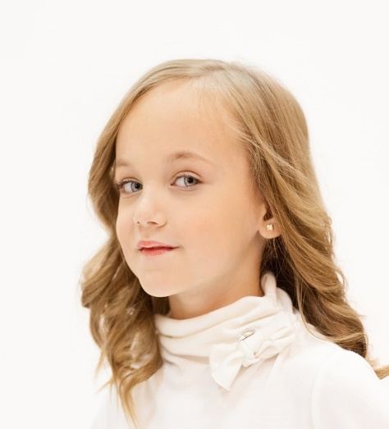](https://www.google.com/url?sa=i&rct=j&q=&esrc=s&source=images&cd=&cad=rja&uact=8&ved=0ahUKEwikj-P3wozMAhUCjz4KHdX3BpoQjRwIBw&url=https://pixabay.com/en/girl-young-blue-eyes-look-looking-545510/&psig=AFQjCNG7ynn76sexEoPYz9Od2pSPmWw2Xw&ust=1460668118494125)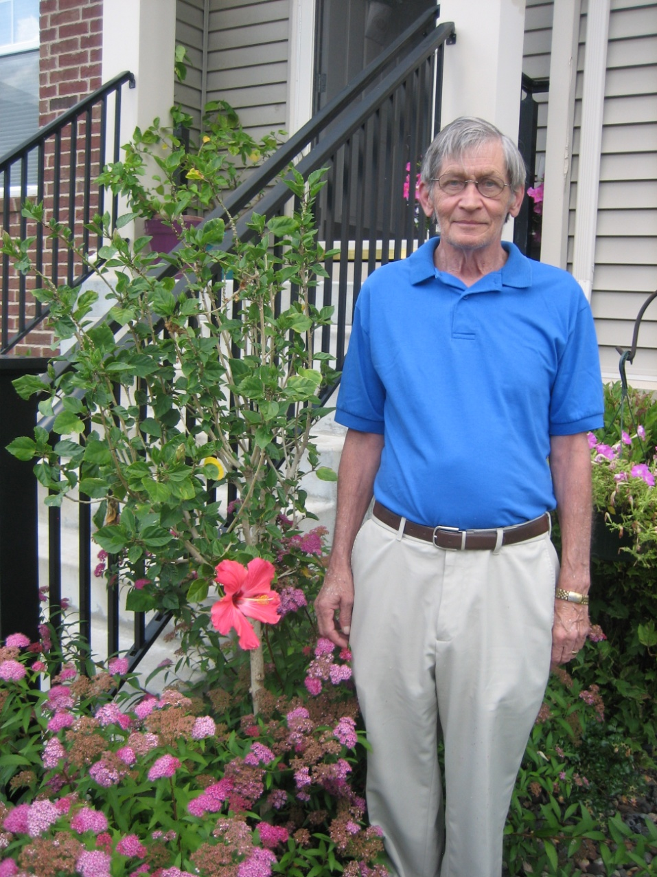

Insert Parent Picture or delete this message box and use this photo.

Change name and insert picture of giver of book

Change name and insert picture of the child

Single parent ok.

[](http://www.google.com/url?sa=i&rct=j&q=&esrc=s&source=images&cd=&cad=rja&uact=8&ved=0ahUKEwjQrLOj3azMAhWKMz4KHc6OCd0QjRwIBw&url=http://dexacor.com/studiojsite/service/father_son/&psig=AFQjCNHQ2vpV5Hn3_wPnaROuUGSLDjdgAQ&ust=1461774707557299)

**“Cancel Halloween what a thought.**

**The children will be distraught.**



Extended family or neighborhood photo. Brothers and sisters, your home, and more personalized photo’s will fit in the story.

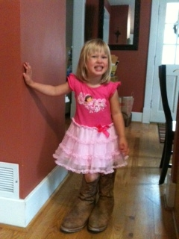

**It’s Easy…….You insert your specifics: Amelia (name), ge 6, lives in Eden Prairie, Minnesota, and more.**

These stories are Microsoft templates designed for the joy of personalization.

Children love seeing themselves, things personal to their loves and lives, references to their birthdays, holidays, and adventures. Our Goals are 1) to increase reading and literacy, 2) to be completely affordable, 3) to entertain both the kids and the adults, and to

**laugh!**

[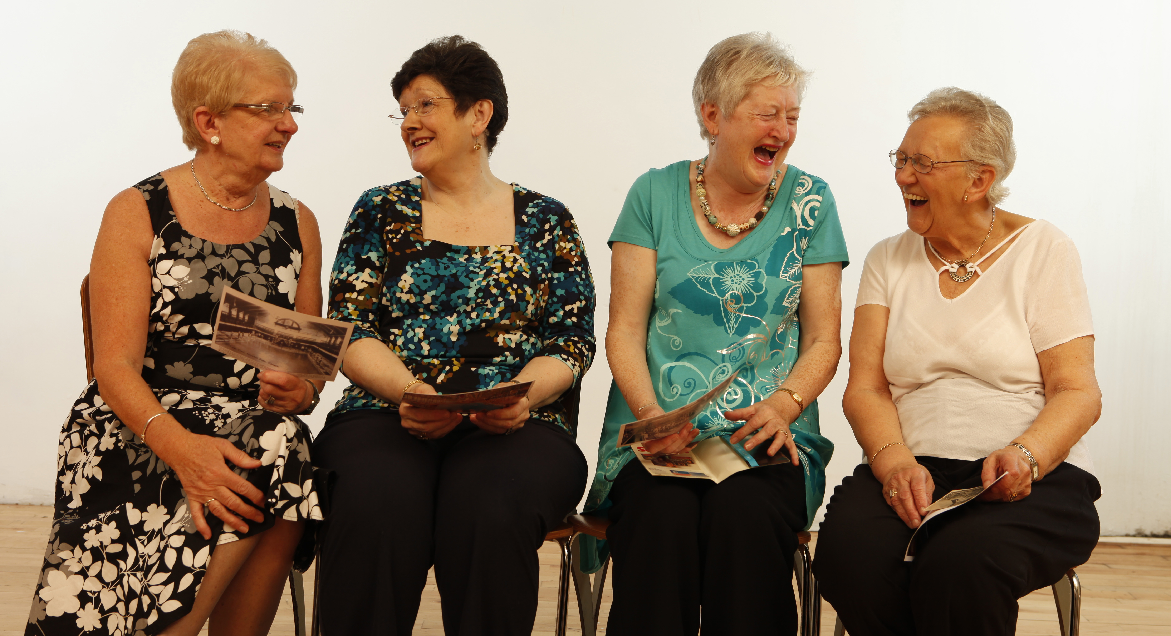](https://www.google.com/url?sa=i&rct=j&q=&esrc=s&source=images&cd=&cad=rja&uact=8&ved=0ahUKEwjls5GJnbzMAhUqkYMKHUgYAXAQjRwIBw&url=https://www.ucl.ac.uk/news/news-articles/1115/101115-change-humour-sign-dementia&psig=AFQjCNGP38hFAVc7FIYqiICV7qh97QAyfg&ust=1462307143818820)

[](http://www.google.com/url?sa=i&rct=j&q=&esrc=s&source=images&cd=&cad=rja&uact=8&ved=0ahUKEwjxz5bR87vMAhWKQiYKHR-fCfYQjRwIBw&url=http://www.mnn.com/lifestyle/arts-culture/stories/why-laughter-contagious&psig=AFQjCNGwMwf6IXwOwXuiJiOo-UvmqmVrMQ&ust=1462296035115983)

[](https://www.google.com/url?sa=i&rct=j&q=&esrc=s&source=images&cd=&cad=rja&uact=8&ved=0ahUKEwjEqvfA9LvMAhVGQCYKHW3_AJgQjRwIBw&url=https://www.pinterest.com/pin/445715694340861062/&psig=AFQjCNGwMwf6IXwOwXuiJiOo-UvmqmVrMQ&ust=1462296035115983)

[](http://www.google.com/url?sa=i&rct=j&q=&esrc=s&source=images&cd=&cad=rja&uact=8&ved=0ahUKEwiKsdev87vMAhWGOiYKHRtMCjAQjRwIBw&url=http://www.personal.psu.edu/afr3/blogs/SIOW/2011/09/why-laughing-makes-you-feel-so-good.html&psig=AFQjCNGwMwf6IXwOwXuiJiOo-UvmqmVrMQ&ust=1462296035115983)

Copyright © 2016 Xanadu Inc. See permitted uses and licensing. 11348 Stratton Ave, Eden Prairie MN 55344. [Xanaducorporate@gmail.com](mailto:Xanaducorporate@gmail.com), 952-920-9160 or 952-240-6710

General Instructions and Word Tips. Make a copy of the story template first.

1. The templates are designed to be printed with a color printer. Almost any printer will work. Office Depot, Staples, Kinkos, and others offer color printing. The templates are designed to be printed on one side only. Binding for two sided printing will require movement of some of the text and objects.
2. The templates should work in any version of Microsoft word, although the program may ask for conversion to a newer version.
3. The story templates are all in 81/2 X 11. There are many binding options including binders and/or staples with stock covers. If you are using a binder we recommend a see through cover.
4. Text boxes: From Word menu (Insert/Text Box/Draw) Almost all of the images and text are enclosed in a text box. This makes them easier to move and position. By clicking on the side of the image the border can be located. Images also have borders most of which do not show up when printed. To insert a picture or text into a box draw the box first, then cut the item to be inserted, then click inside the text box. With the cursor in the text box paste.
5. Checking: Check after inserting pictures to see if pages are proper. Sometimes the process will push down all of the following items. Either enter undue and repeat or find the cursor spot to delete lines.